Switching Miraserv from Production to Testing

- Stop Miraserv
– Run StopMiraServ.exe in C:\Program Files\Eigen\MiraServ to stop Miraserv.

IMPORTANT
You MUST STOP Miraserv before you replace the EIGEN folder.

- Update the Miraserv folder
– Replace the Miraserv folder created in C:\Program Files with the Miraserv folder located in \\Svbhq015\Vol2\IT\GIS-Install-Utility\GISClientInstallation\EIGEN Miraserv Installation\EigenTesting.

- Start Miraserv
– Run StartMiraServ.exe in C:\Program Files\Eigen\MiraServ to start Miraserv.
– The message displayed on the PINpad will change from
INITIALIZING EMV PLEASE WAIT to INITIALIZING EMV COMPLETE to OPEN.

- Configure GIS
– Open up the GIS configuration file by entering C:\WINDOWS\gis.ini in the Run window to open up gis.ini.
– Change the TerminalID in gis.ini to EIGEN.
– Change the Credit Card Provider in gis.ini to EIGEN.
– Save the file.

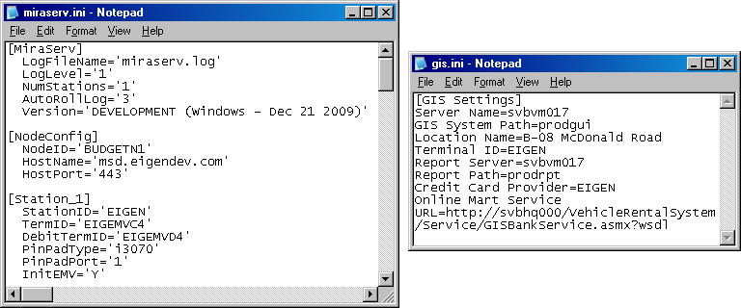
Figure 1: The ini files for testing.

Switching Miraserv from Testing to Production

- Stop Miraserv
– Run StopMiraServ.exe in C:\Program Files\Eigen\MiraServ to stop Miraserv.

IMPORTANT
You MUST STOP Miraserv before you replace the EIGEN folder.

- Update the Miraserv folder
– Replace the Miraserv folder created in C:\Program Files with the Miraserv folder located in \\Svbhq015\Vol2\IT\GIS-Install-Utility\GISClientInstallation\EIGEN Miraserv Installation\EigenProduction.

3a. (If a PINpad is assigned) Configure Miraserv and the PINpad
– Open the miraserv.ini file in C:\Program Files\Eigen\MiraServ.
– Change NodeID, StationID, TermID and DebitTermID with reference to the VAN Budget Spreadsheet.xls located in \\Svbhq015\vol2\IT\GIS-Install-Utility\GISClientInstallation\EIGEN Miraserv Installation.
– Hook the PINpad up to the COM port of the CSR’s work station (in miraserv.ini, PinPadPort = '1' if you connect the PINpad to the COM port).

NOTE
If the work station does not have a COM port, try the following steps:
a. Connect PINpad to the USB port via a USB serial converter.
b. Install the drivers from \\Svbhq015\IT\GIS-Install-Utility\GISClientInstallation\EIGEN Miraserv Installation\CDM 2.04.16 WHQL Certified\i386.
c. Change PinPadPort in miraserv.ini to '3'.

– Initialize EMV by setting InitEMV to 'Y'.
– Save the file.

3b. (If no PINpad exists) Configure Miraserv
– Open the miraserv.ini file in C:\Program Files\Eigen\MiraServ.
– Change NodeID, StationID and TermID with reference to the VAN Budget Spreadsheet.xls located in \\Svbhq015\vol2\IT\GIS-Install-Utility\GISClientInstallation\EIGEN Miraserv Installation.
– Set DebitTermID to 'NOTERMID'.
– Save the file.

- Start Miraserv
– Run StartMiraServ.exe in C:\Program Files\Eigen\MiraServ to start Miraserv.
– The message displayed on the PINpad will change from
INITIALIZING EMV PLEASE WAIT to INITIALIZING EMV COMPLETE to OPEN.
- Configure GIS
– Open up the GIS configuration file by entering C:\WINDOWS\gis.ini in the Run window to open up gis.ini.
– Ensure that the StationID in miraserv.ini matches the TerminalID in gis.ini.
– Change the Credit Card Provider in gis.ini to EIGEN.
– Save the file.

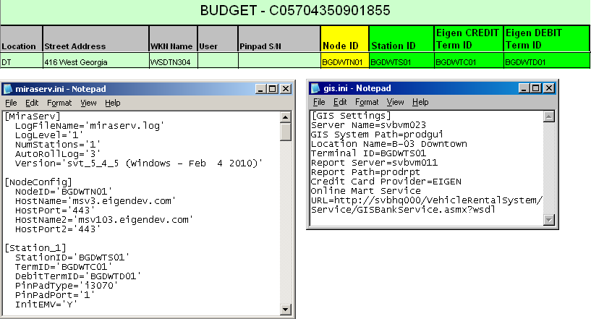
Figure 2: The final look of both .ini files with reference to VAN Budget Spreadsheet.xls.

